Gyanmanjari Innovative University



GYANMANJARI COLLEGE OF COMPUTER APPLICATION

A

Project Report On

## Project Title

Under subject of

Major Project - MCAXX14521

MCA, Semester – IV

Submitted By

Student1 Name Enrollment Number

Student2 Name Enrollment Number

Student3 Name Enrollment Number

#### Prof.

(Faculty Guide)

Prof. Kashyap Dave

(Head of the Department)

Academic Year 2024-2025

**GYANMANJARI COLLEGE OF COMPUTER APPLICATION BHAVNAGAR**

## CERTIFICATE

*This is to certify that the project ton “PROJECT NAME” has been satisfactorily carried by Student Name. (Er.no.) under my guidance in the fulfillment of the* Major Project -MCAXX14521  *work during the academic year 2024-2025.*

1. *Student Name*

Internal Guide Head of the Department

Prof. Prof. Kashyap Dave

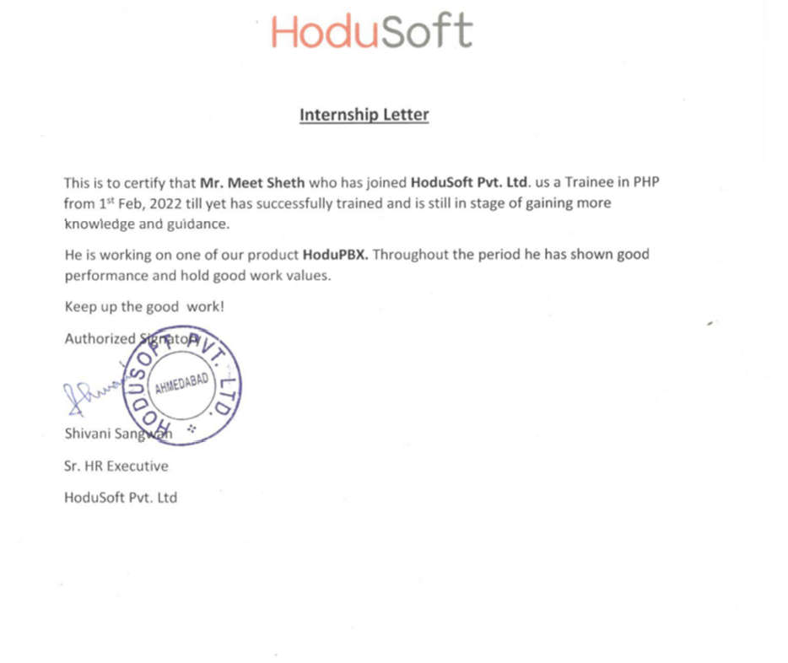

**ACKNOWLEDGEMENT**

## ABSTRACT

**INDEX**

|  |  |  |
| --- | --- | --- |
| **Sr No.** | **Chapter Name** | **Page No.** |
|  | **ACKNOWLEDGEMENT** | **I** |
|  | **ABSTRACT** | **II** |
|  | **Finger List** | **IV** |
|  | **Table List** | **IV** |
| 1. | **Chapter 1: Introduction** |  |
| 2. | **Chapter 2: Requirement Determination & Analysis** |  |
| 3. | **Chapter 3:SystemDesign** |  |
|  | 3.1UseCaseDiagram |  |
|  | 3.2ClassDiagram |  |
|  | 3.3InteractionDiagram |  |
|  | 3.4ActivityDiagram |  |
|  | 3.5DataDictionary |  |
| 4. | **Chapter 4: Development** |  |
|  | 4.1 CodingStandards |  |
|  | 4.2 ScreenShots |  |
| 5. | **Chapter 5: Proposed Enhancement** |  |
| 6. | **Chapter 6: Conclusion** |  |
| 7. | **Chapter 7: Bibliography** |  |

**Finger List**

|  |  |  |
| --- | --- | --- |
| **Sr No.** | **ChapterName** | **PageNo.** |
| 1 | Use Case Admin | 7 |
| 2 | Use Case Tenant | 8 |

**Table List**

|  |  |  |
| --- | --- | --- |
| **Sr No.** | **ChapterName** | **PageNo.** |
| 1 | Project Profile | 3 |
| 2 | Tenant Master | 13 |

# Introduction

# Requirement Determination & Analysis

# System Design

* 1. 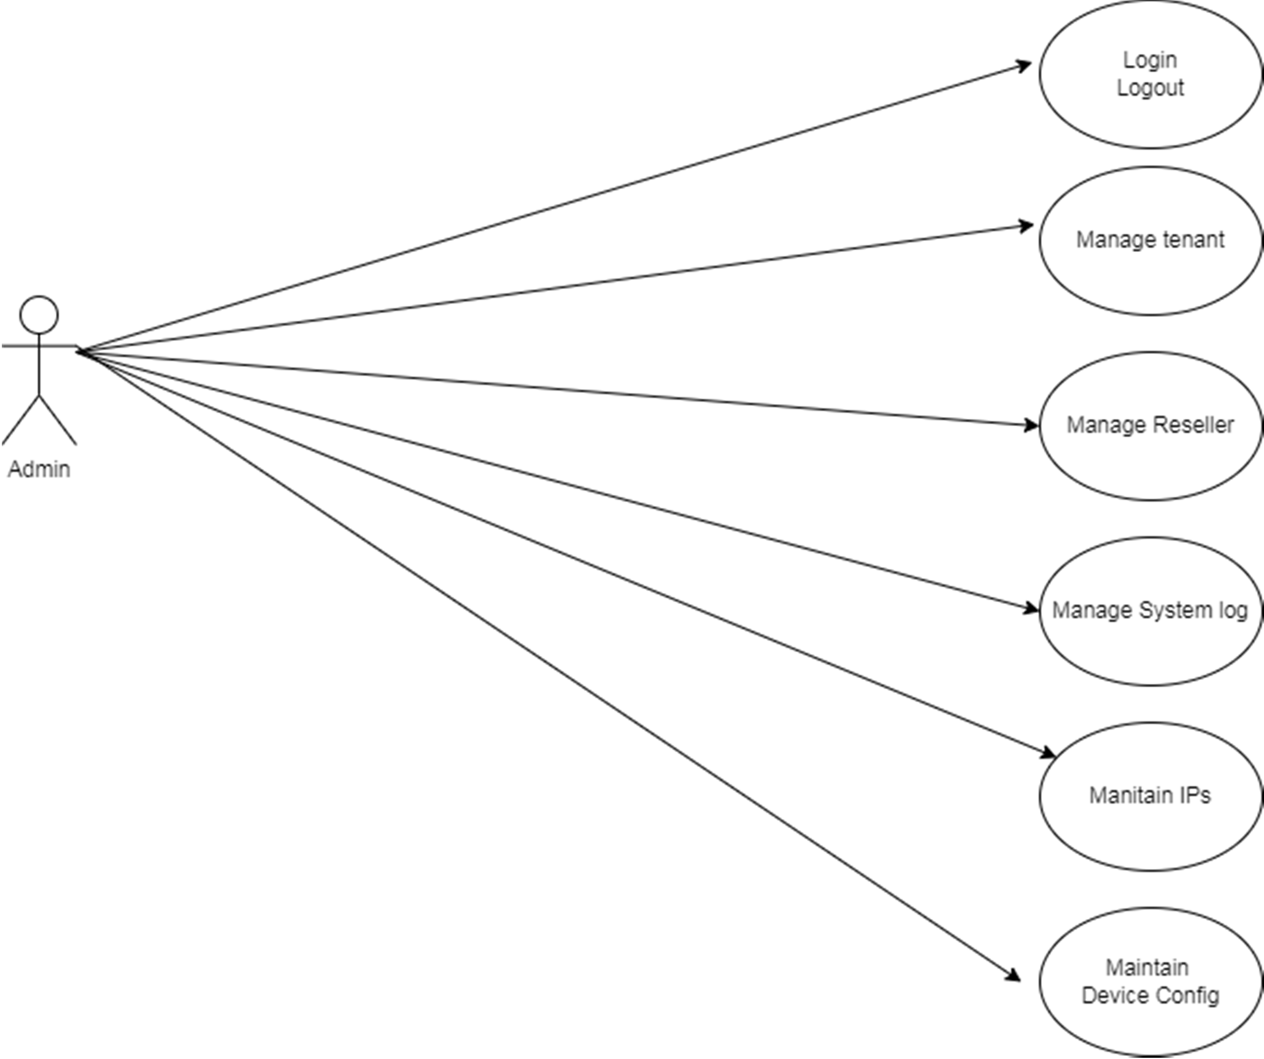**Use case Diagram:**

Fig1:use case Admin

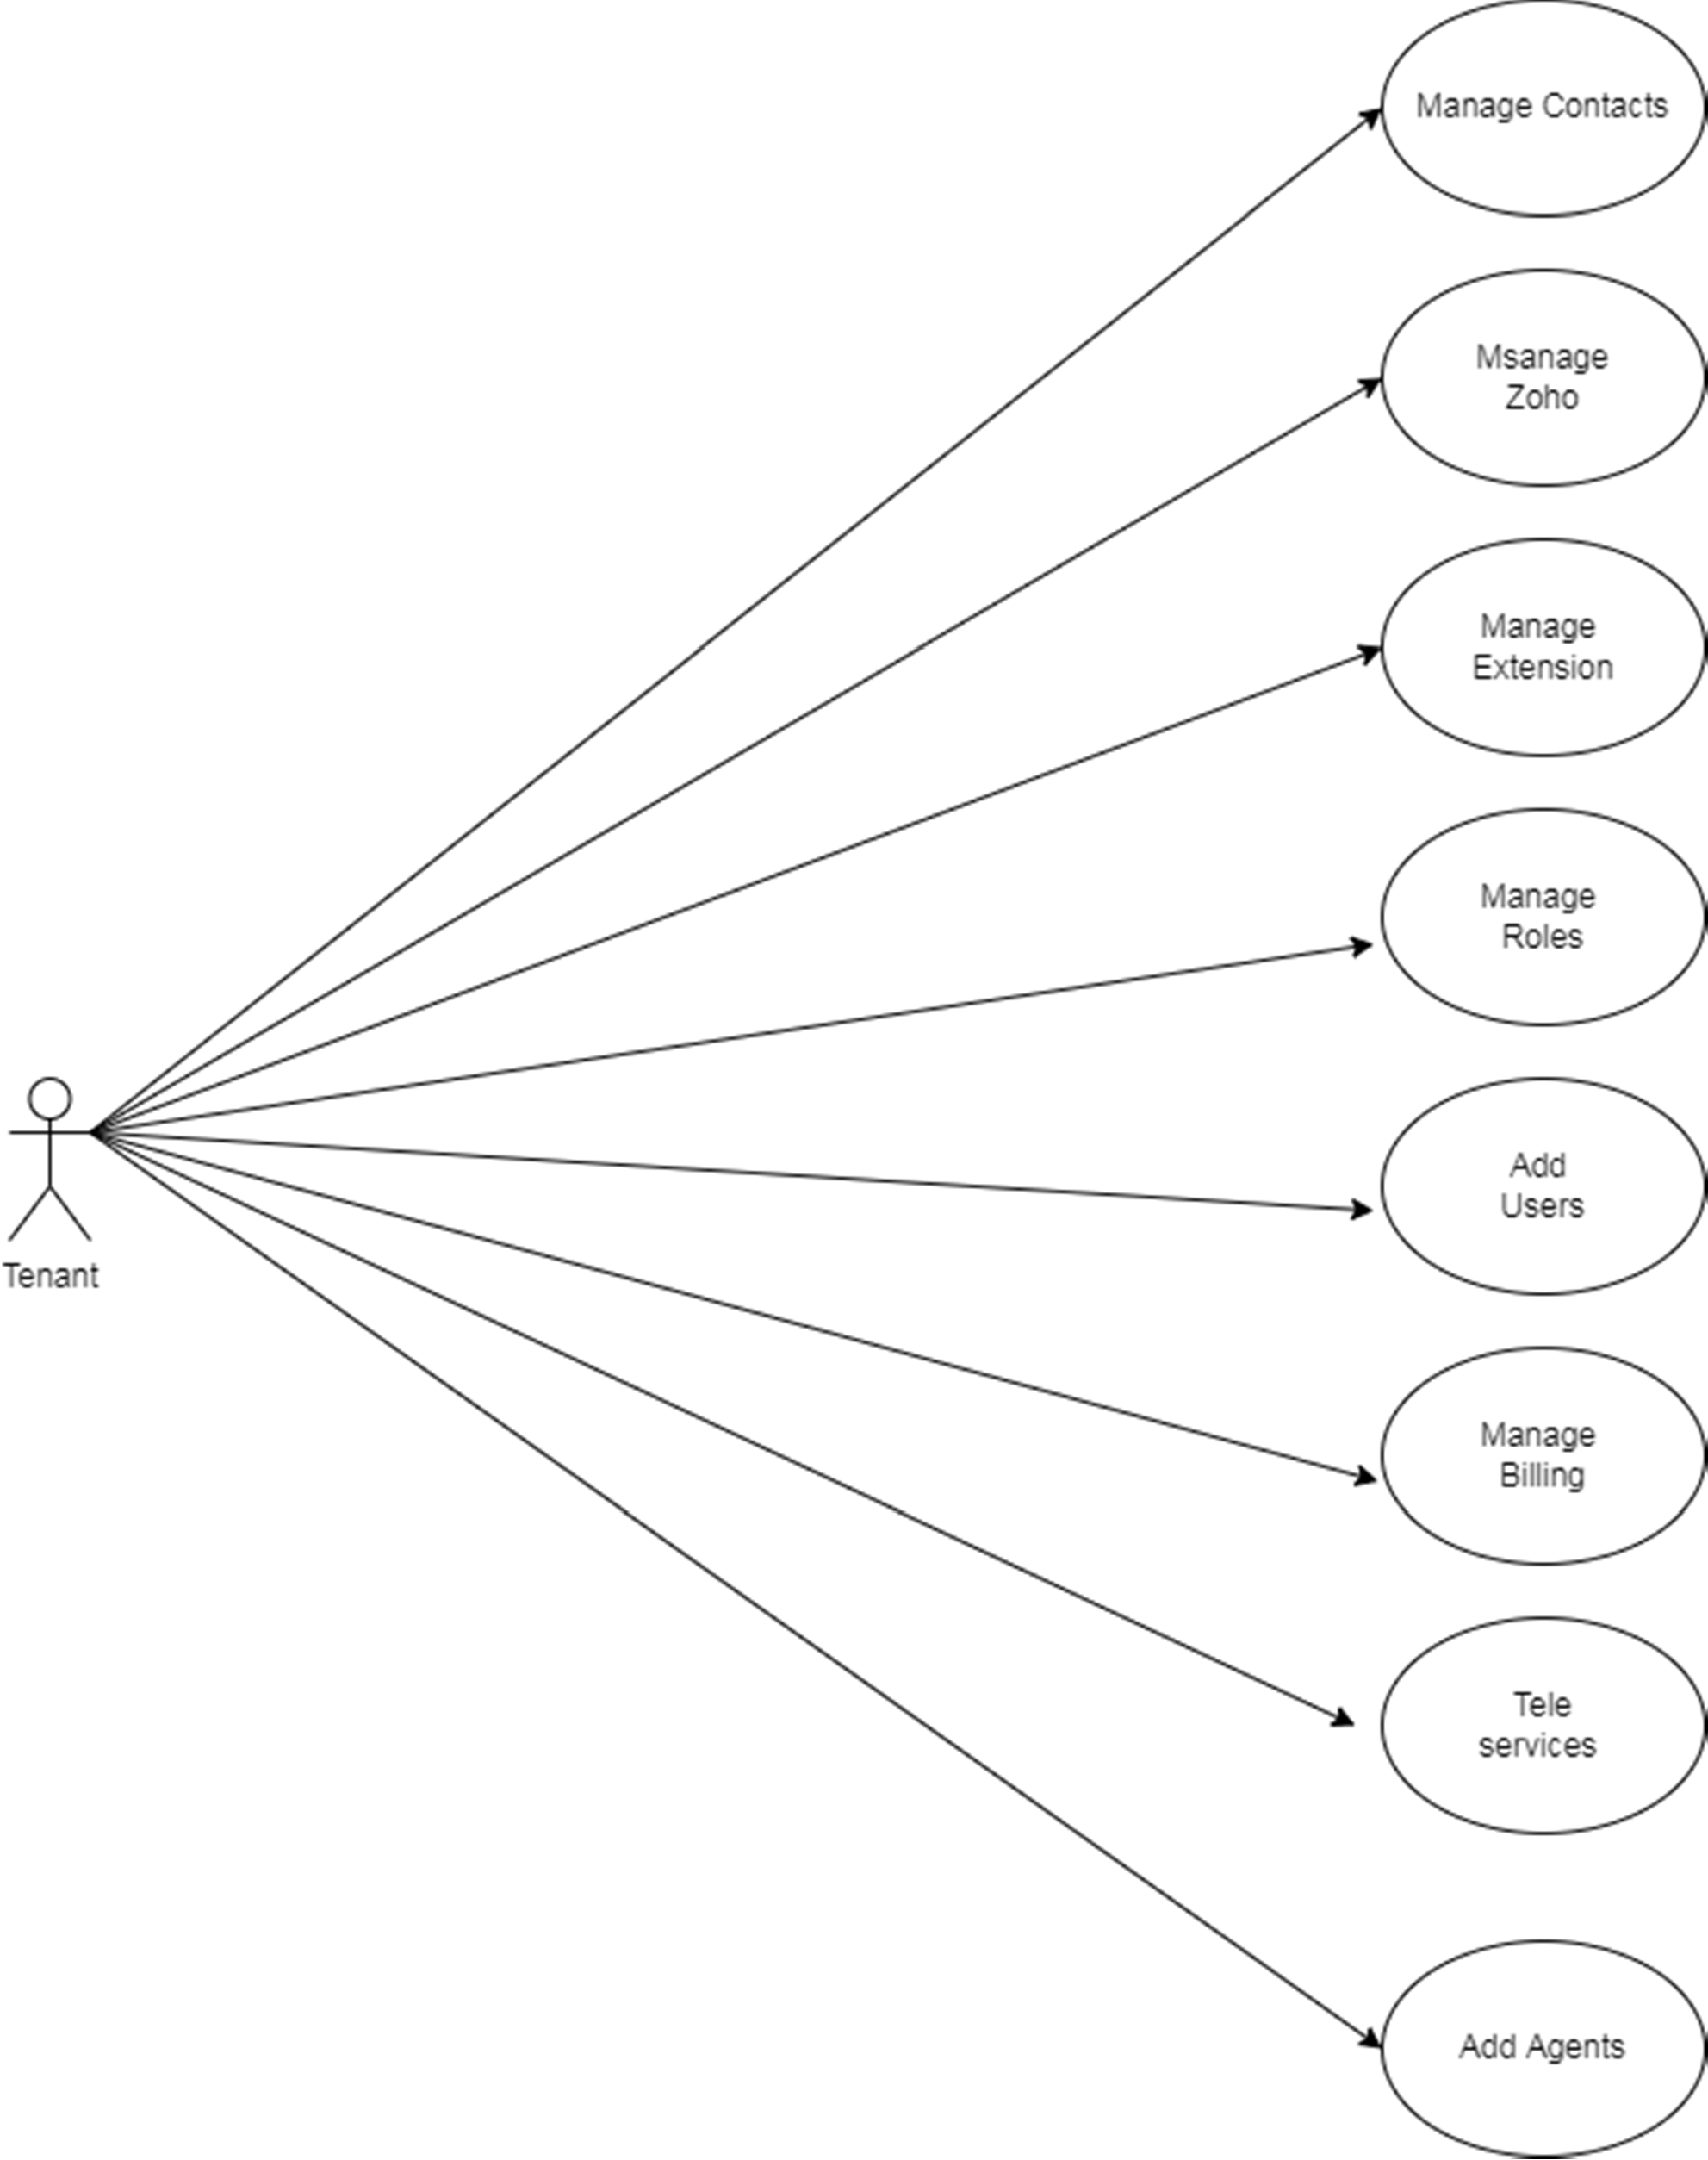

Fig2:use case tenant

# Class Diagram:

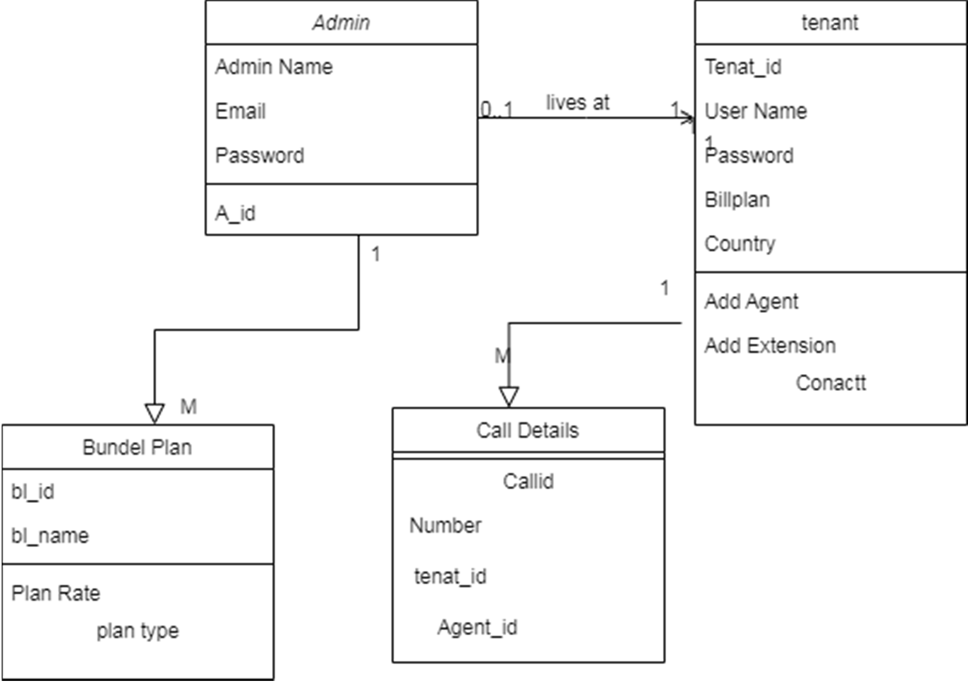

Fig3:Class Diagram

# Interaction Diagram:

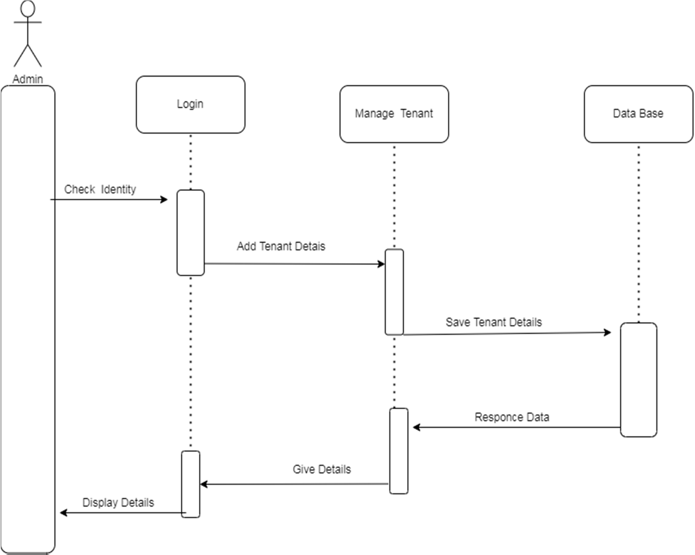

Fig4:Intration Diagram

# Activity Diagram:

Fig5:Activity Diagram

# 3.5. Data Dictionary:

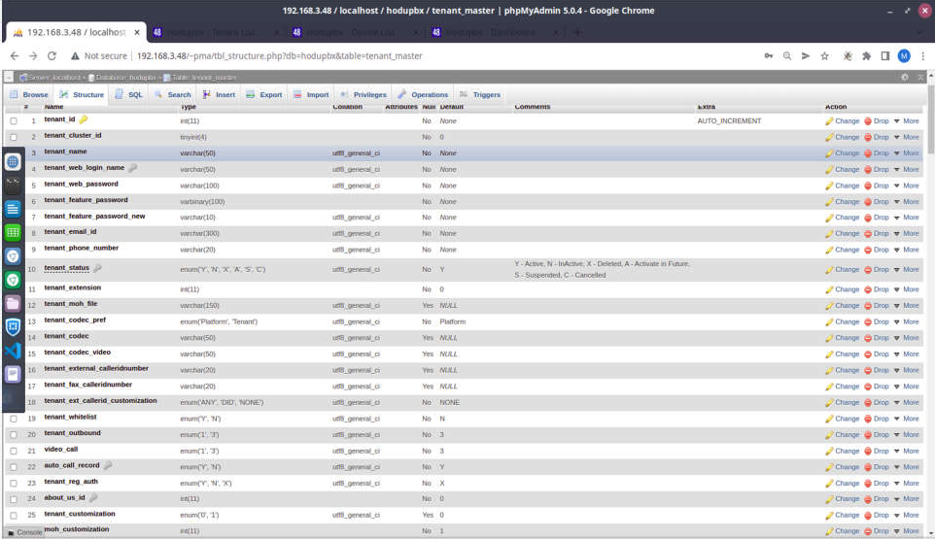

Fig06:Tenant Master

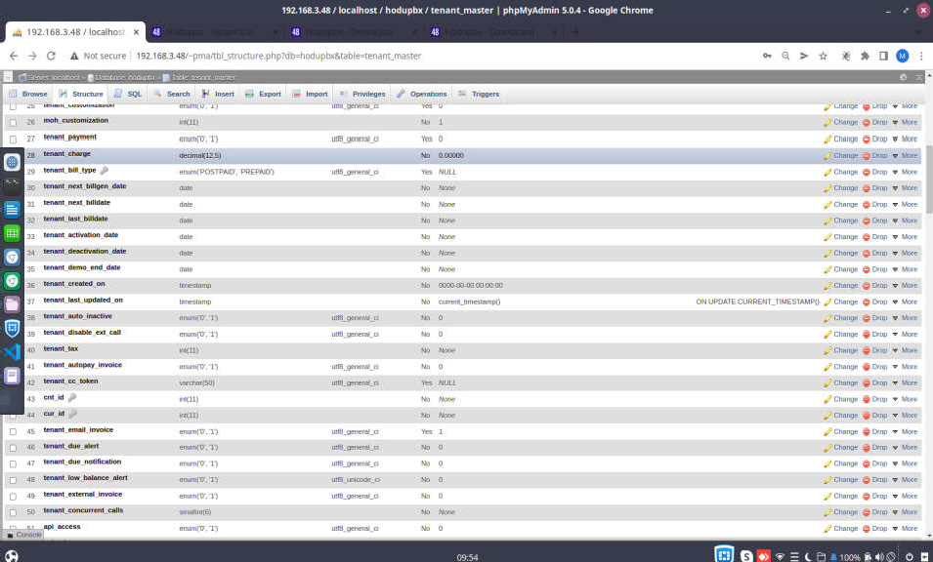

Fig06_1:-Tenant Master

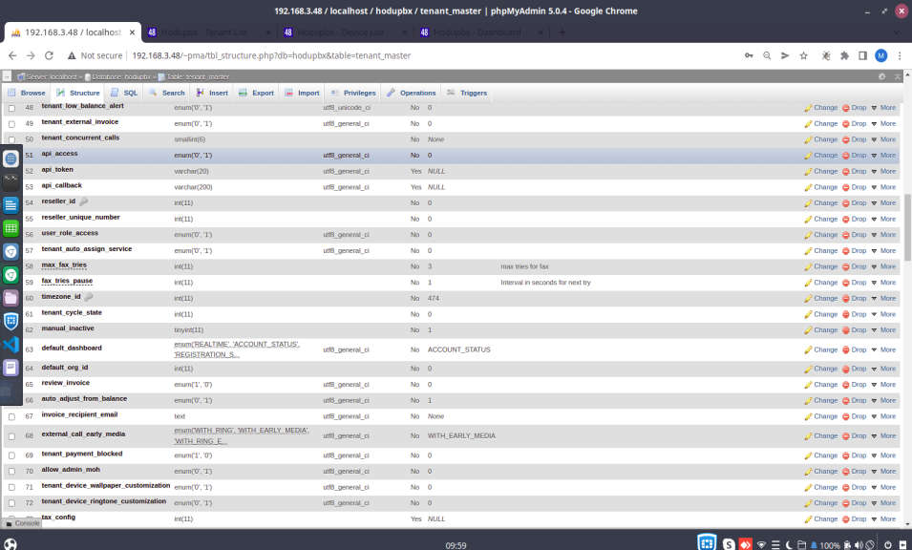

Fig06_2:-Tenant Master

|  |  |  |  |  |
| --- | --- | --- | --- | --- |
| **Sr N**  **o.** | **Filed Name** | **Data type** | **Constrain** | **Descrip tion** |
| 1 | bl_id | int(11) | Auto_incre ment | Unique  Id of |
|  |  |  |  | Blackli |
|  |  |  |  | st |
|  |  |  |  | number |
| 2 | bl_num ber | varchar(20) | Not Null | Number of a device |
| 3 | bl_desc | varchar(20) | Not Null | descripti on |
| 4 | bl_type | enum(‘BOTH’,’IN’,’OUT’) | Not Null | Add A type of Calling |
| 5 | bl_by | enum(‘ADMIN’,’EXETESION’,’TENAN | Not Null | Add by |
|  |  | T’,’RESELLER’) |  | which |
|  |  |  |  | person |
|  |  |  |  | is |
|  |  |  |  | Added |
| 6 | bl_relat e | int(11) | Not Null | Add a relation of number |
| 7 | reseller  _id | int(11) | Not Null | Add a resller number |
| 8 | tenant_ id | int(11) | Not Null | Add tenant id |

Table 03:-black list master

|  |  |  |  |  |
| --- | --- | --- | --- | --- |
| **Sr No.** | **Filed Name** | **Data type** | **Constrain** | **Description** |
| 1 | pc_id | int(11) | Auto  increment | Pc number of  your system |
| 2 | config_name | varchar(150) | Not Null | Configuration  Name or define name |
| 3 | config_value | varchar(500) | Not Null | Configuration  value |
| 4 | config_value_new | varchar(500) | Not Null | Change in  value |

Table04:-prov_configurations

|  |  |  |  |  |
| --- | --- | --- | --- | --- |
| **Sr No.** | **Filed Name** | **Data type** | **Constrain** | **Description** |
| 1 | Id | int(11) | Auto_increment | Unique id for  all |
| 2 | Name | Varchar(250) | Not Null | Name of  ringtone |
| 3 | file_url | Varchar(1500) | Not Null | Url of a file |
| 4 | default_access | Enum(0,1) | Not Null | Access of an  ringtone |
| 5 | Created_time | datetime | Not Null | For a store date  and time |
| 6 | update_time | datetime | Not Null | Updated time  and date |
| 7 | tenant_id | int(11) | Forgen key | Get a refrence |

Table05:-device_ringtone

|  |  |  |  |  |  |  |
| --- | --- | --- | --- | --- | --- | --- |
| **Sr No.** | **Filed Name** | **Data type** | **Constrain** | **Description** | | |
| 1 | hd_id | int(11) | Auto_increamen t | For a take a id of a holiday | | |
| 2 | hd_name | varchar(25) | Not Null | Name holiday | of | a |
| 3 | hd_date | Date | Not null | Date holiday | of | a |
| 4 | hd_start_date | Time | Not null | Time of leave | | |
| 5 | hd_end_date | Time | Not null | Time of enter | | |
| 6 | hd_reperat | Int(1) | Not null | Reapeate yes | | |
| 7 | tenant_id | Int(11) | Forgen key | Id which is make a refrence | | |
| 8 | hd_grp_id | int(11) | Forgen key | Refrence of group key | | |

Table 06:-holiday_master

|  |  |  |  |  |
| --- | --- | --- | --- | --- |
| **Sr No.** | **Filed Name** | **Data type** | **Constrain** | **Description** |
| 1 | hd_grp_id | Int(11) | Auto_increment | Unique key |
| 2 | hd_grp_name | Varchar(50) | Not Null | Name of group |
| 3 | hd_grp_member | Mediumtext | Not null | Members of selection |
| 4 | hd_grp_status | Enum(‘1’,’0’) | Not Nul | Status is on or not |
| 5 | tenant_id | int(11) | Forgen key | Refrence |
| 6 | reseller_id | Int(11) | Forgen key | Refrecne |

Table07:-holiday_group_master

|  |  |  |  |  |
| --- | --- | --- | --- | --- |
| **Sr No**  **.** | **Filed Name** | **Data type** | **Constrain** | **Descriptio n** |
| 1 | vg_id | Int(11) | Auto_increme nt | Voice mail id |
| 2 | vg_name | Varchar(50) | Not null | Name of voice mail |
| 3 | vg_desc | Varchar(521) | Not null | Description of a voice mail |
| 4 | vg_type | enum(‘UPLOAD’,’RECORDIN G’) | Not null | Voice mail type |
| 5 | vg_file | Varchar(100) | Not Null | Content of a file |
| 6 | vg_status | Int(2) | Not null | Status of a voicemail |
| 7 | vg_extension_i d | Int(11) | Not Null | Which extion made this |
| 8 | vg_created | Datetime | Not null | Date of creation |

Table 08:-voicemail_greetings

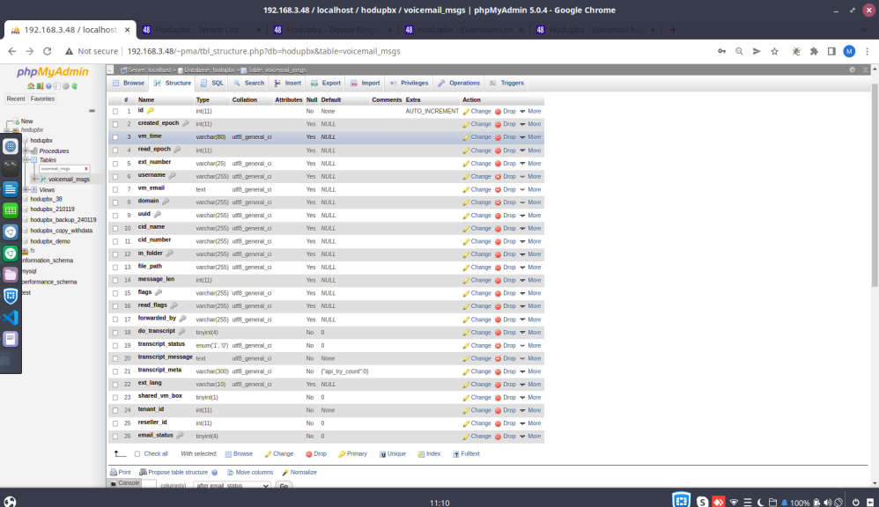

Fig07:-voicemail_msgs

# Development

* 1. **Coding Standards:**

1. **Naming Convention:**
   * Give meaningful name to the variables, methods and classes.
   * Use Camel Case for defining variable names. Camel case refers to words having the firstletter of an identifier is lowercase and the first letter of each subsequent concatenated words is capitalized. Example: btnSubmitClick .
   * Name of the classes should be in Pascal case. Pascal Case is one in which the first letterin the identifier and the first letter of each subsequent concatenated word are capitalised.Example : UploadPhoto.swift

### Organization of Files :

* + This is section that defines how we need to place the files used in the website and underwhat section:
  + We should follow MVC architecture. In which all the model classes or fragment classesshould be in model folder.
  + All controllers should be separate and view should be separate as well.
  + There should be a section to define all Constants for the app. The constants shouldinclude the following:
  + Constants for dimensions. For Eg: row height = 80, number of cells = 5 etc.
  + Constants for URLs used in the app. This can be for projects related to webservices. Thisshould be at one place.
  + All the image name should be defined at one place and there should be no hard-codedvalues in the code.
  + All the code that is used repeatedly should be defined in macros whenever possible.
  + All images, videos and media should be in “resources” folder. There should be subfoldersto save images, medias etc.

### Formatting and Indentation:

The PHP community is large and diverse, composed of innumerable libraries, frameworks, and components.It is common for PHP developers to choose several of these and combinethem into a single project. It is important that PHP code adhere (as close as possible) to a common code style to make it easy for developersto mix and match various libraries for their projects.

Ideally, one should write PHP code that adheres to a known standard. This could be any combination of PSRs, or one of the coding standards made by PEAR or Zend. This meansother developers can easily read and work with your code, and applications that implementthe components can have consistency even whenworking with lots of third-party code.

### 1 Indenting and Whitespace:

* + Use an indent of 2 spaces, with no tabs.
  + Lines should have no trailing whitespace at the end.
  + Files should be formatted with \n as the line ending (Unix line endings), not

\r\n(Windows line endings).

* + All text files should end in a single newline (\n). This avoids the verbose "\ No newline at end of file" patch warning and makes patches easier to read since it's clearer what is being changed when lines areadded to the end of a file.

### 2 Operators:

* + All binary operators (operators that come between two values), such as

+,-,=,

* + !=, ==, >, etc. should havea space before and after the operator, for readability.
  + For example, an assignment should be formatted as $foo = $bar; rather than
  + $foo=$bar;. Unary operators(operators that operate on only one value), such as

▪ ++, should not have a space between theoperator an the

### 3 Casting:

* + Put a space between the (type) and the $variable in a cast: (int)

$my_number.

### 4 Control Structures:

* + Control statements should have one space between the control keywordand opening parenthesis, todistinguish them from function calls.
  + Always use curly braces even in situations where they are

Ptecahgnieca3l2ly | optional. Having them increasesreadability and decreases the likelihood of logic errors beingintroduced when new lines are added.

# ScreenShots Admin Panel

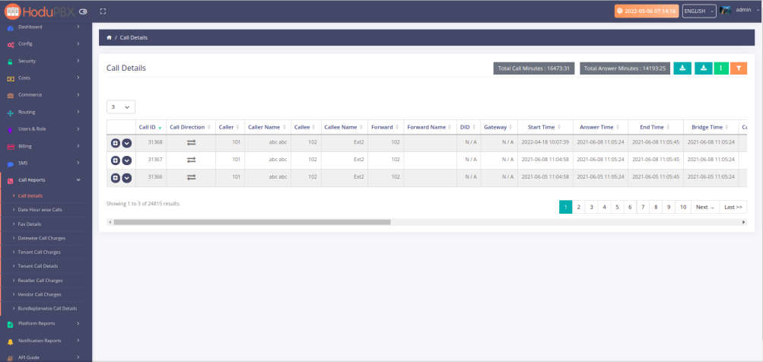

Fig8_01:Call details report

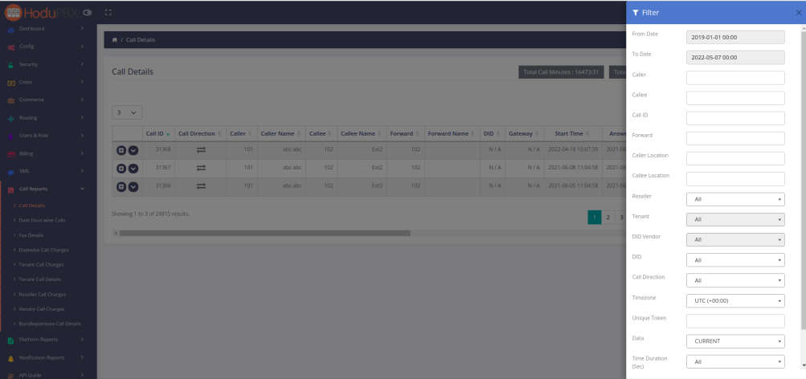

Fig8_02:Call details report

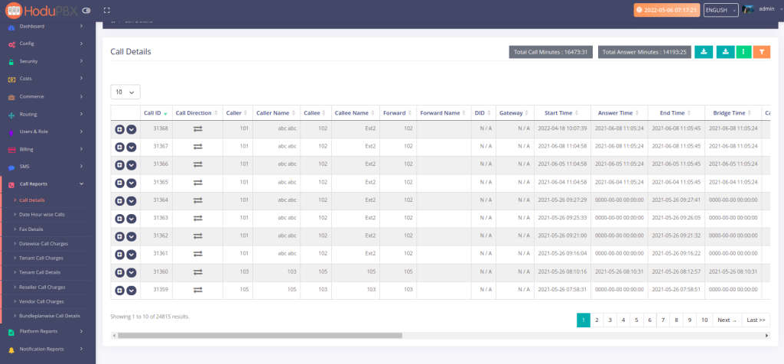

Fig8_03:Call details report

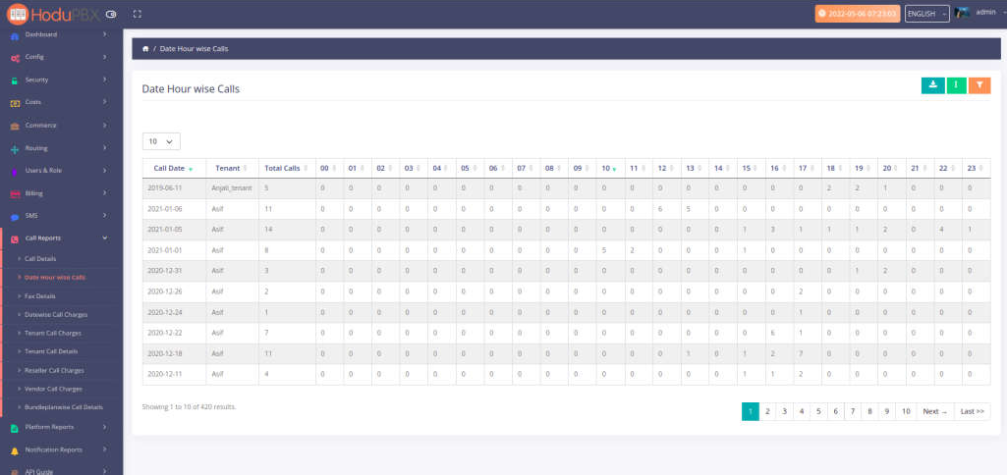

Fig9_01:Call Hours wise Calls

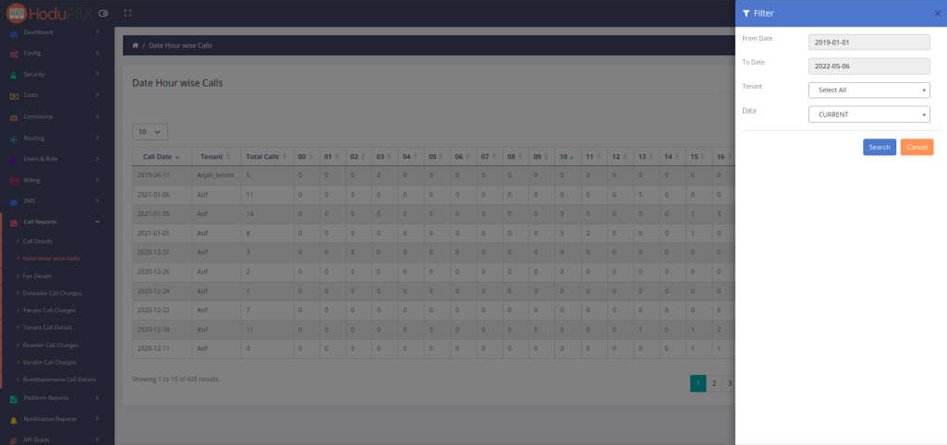

Fig9_02:Call Hours wise Calls

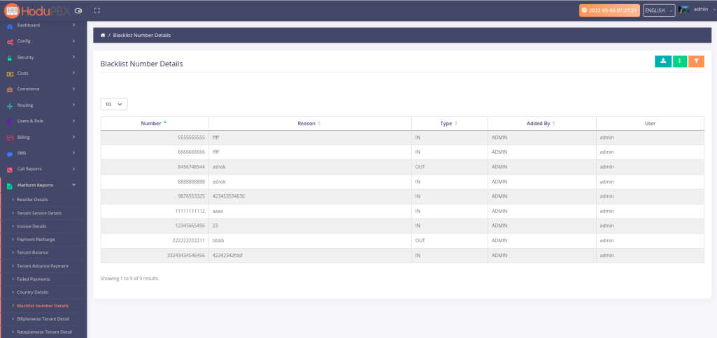

Fig10_01:Blacklist Number Details

Fig10_02:Blacklist Number Details

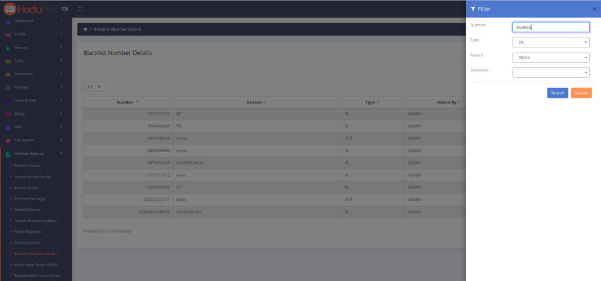

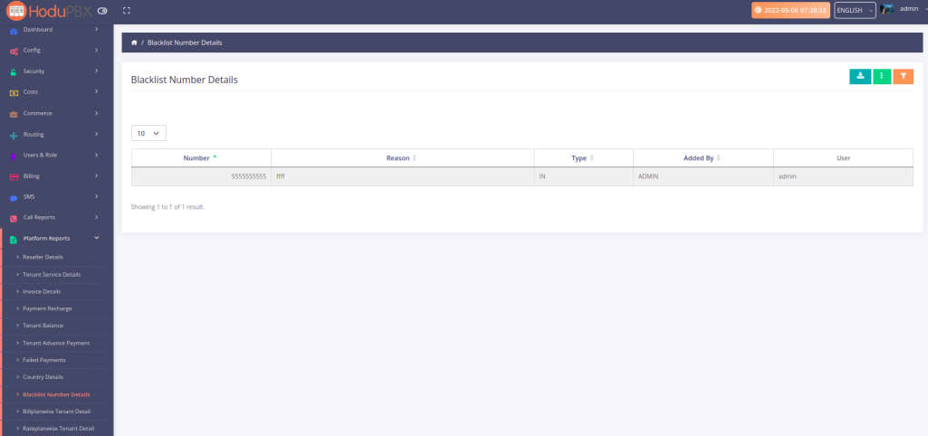

Fig10_03:Blacklist Number Details

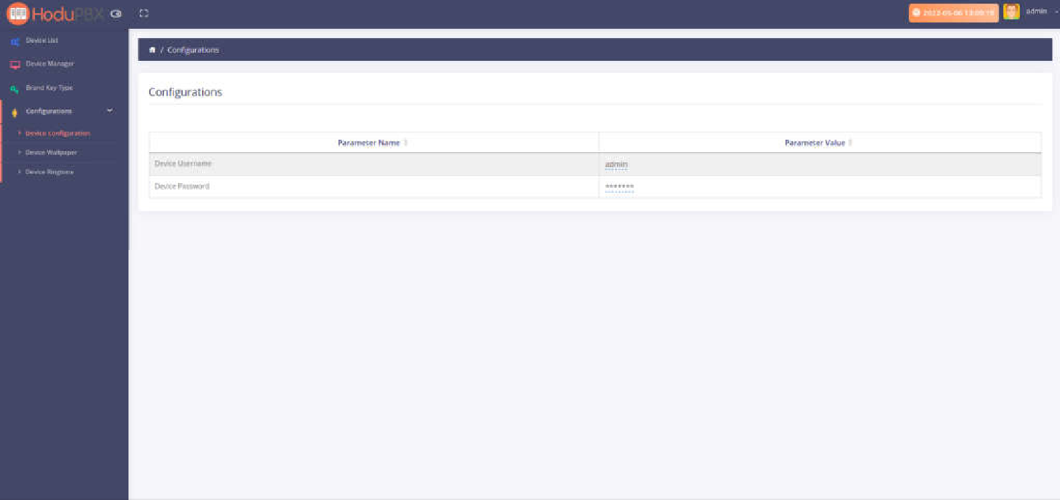

Fig11_1:Device Configration

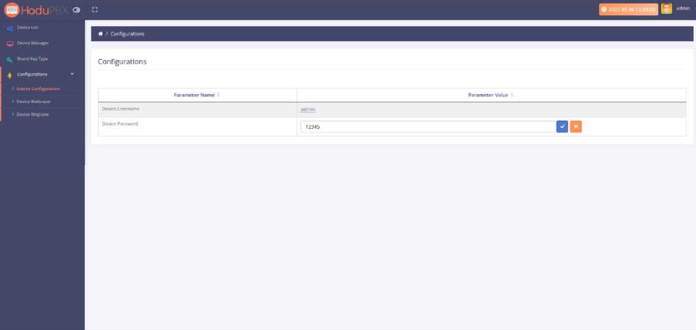

Fig11_2:Device Configration

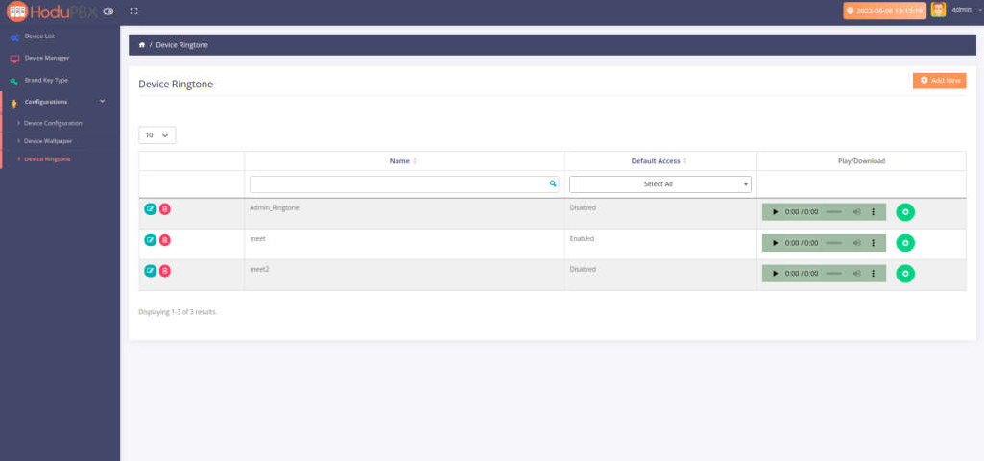

Fig12_1:Device Ringtone

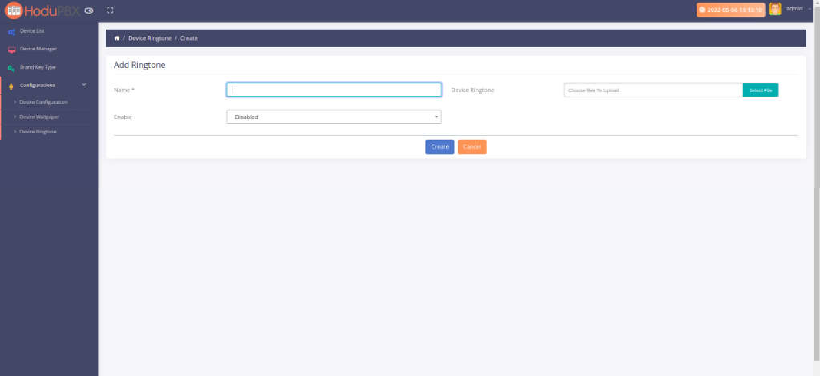

Fig12_2:Device Ringtone

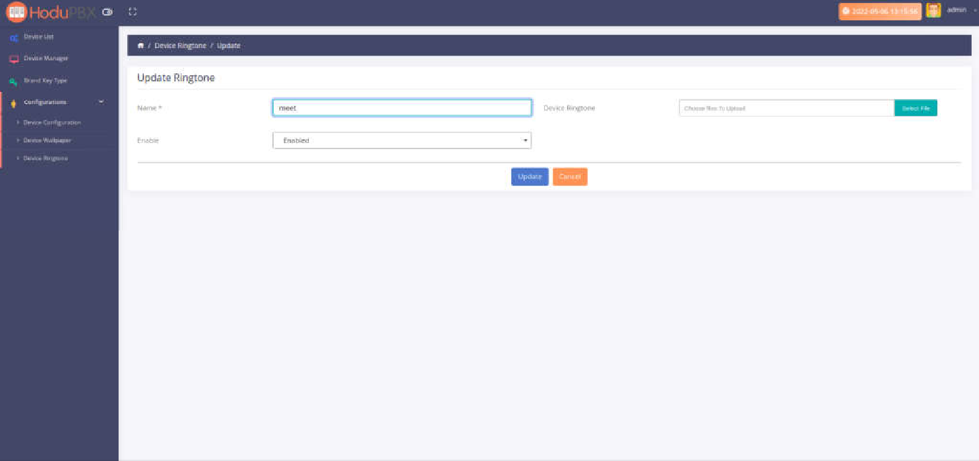

Fig12_3:Device Ringtone

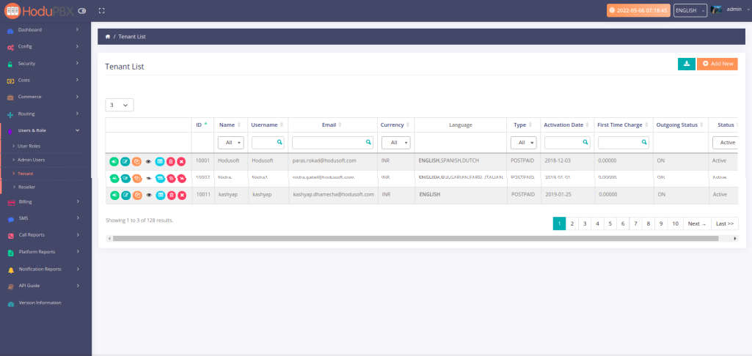

Fig13:Tenant List page

# Tenant panel

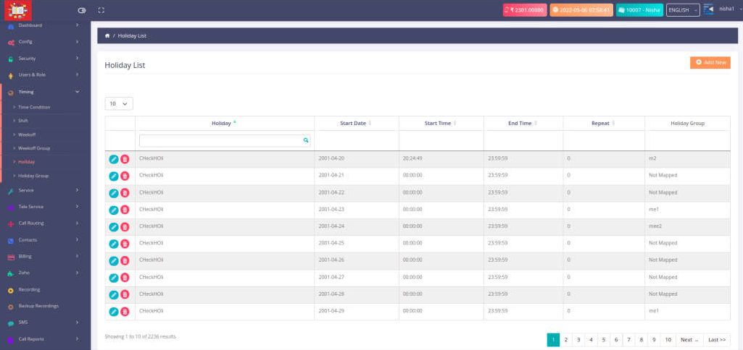

Fig14_01:Holiday

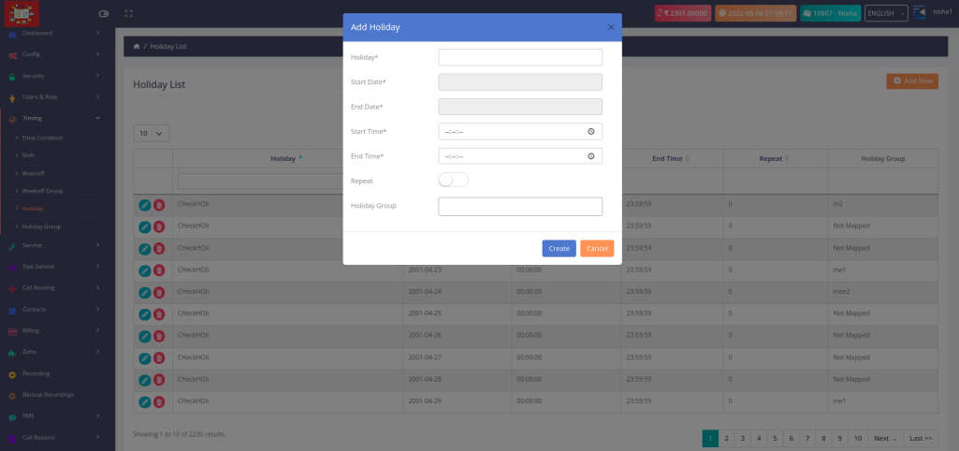

Fig14_02:Holiday

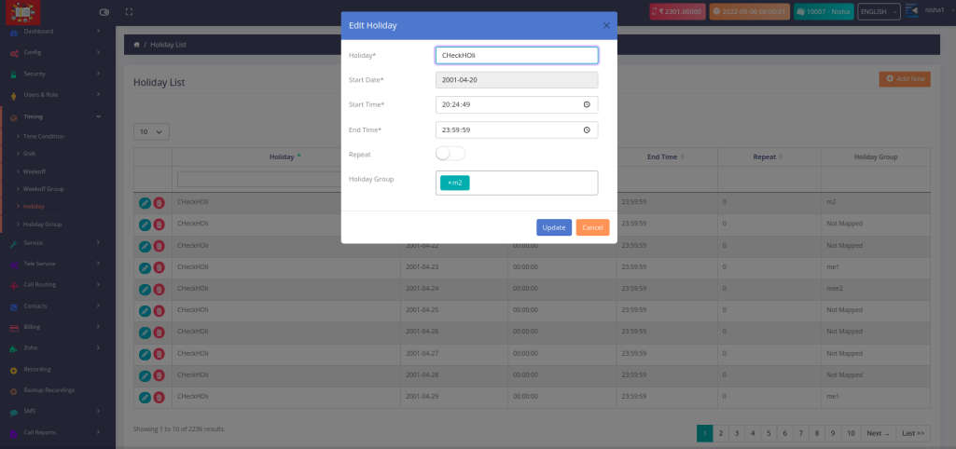

Fig14_03:Holiday

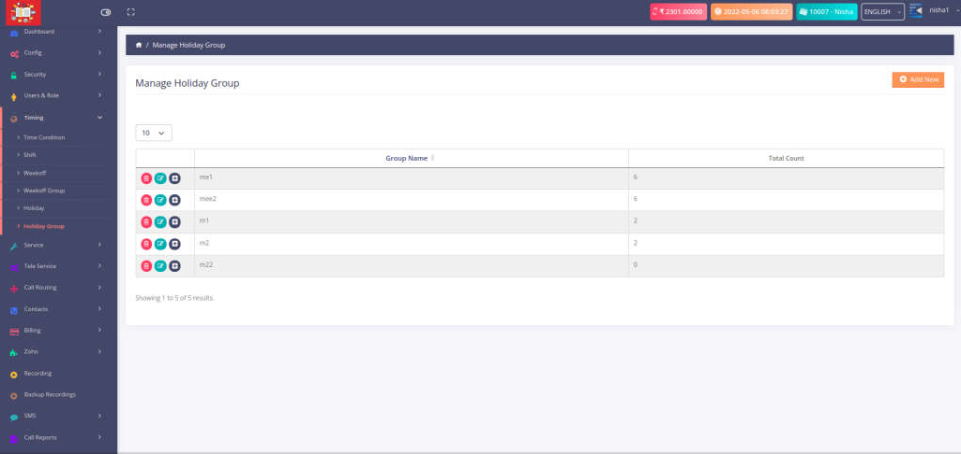

Fig15_01:Holiday Group page

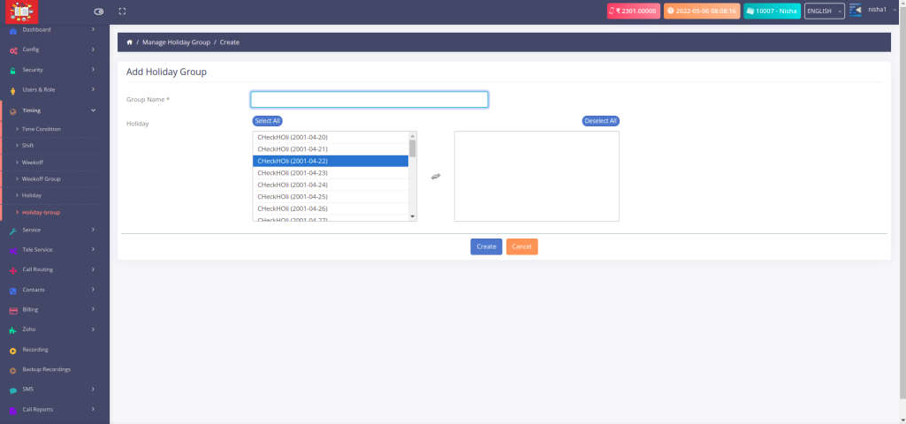Fig15_02:Holiday Group page

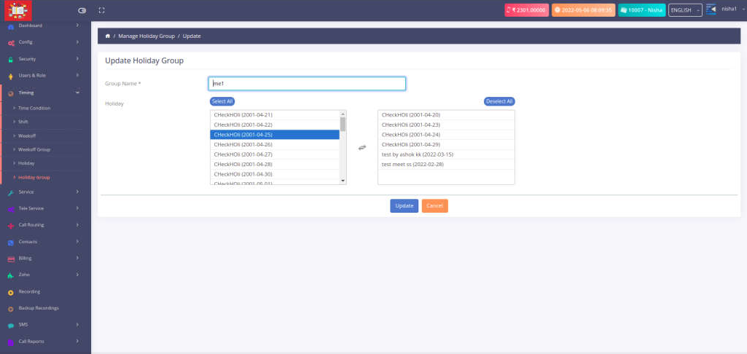

Fig15_2:Holiday Group page

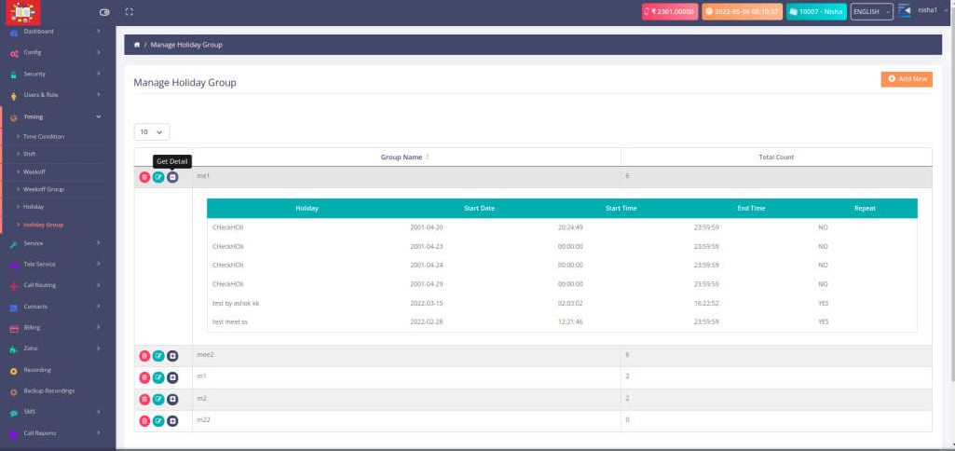

Fig15_3:Holiday Group page

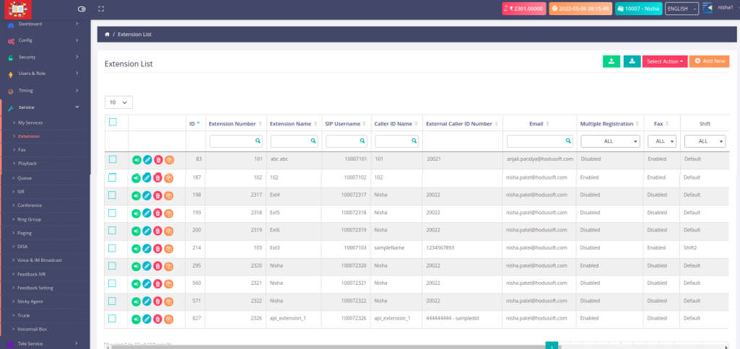

Fig16_01:Voicemail Greetings

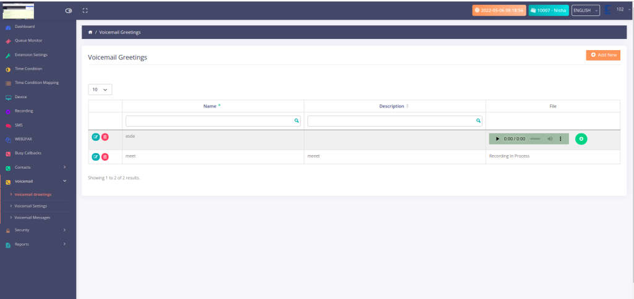

Fig16_02:Voicemail Greetings

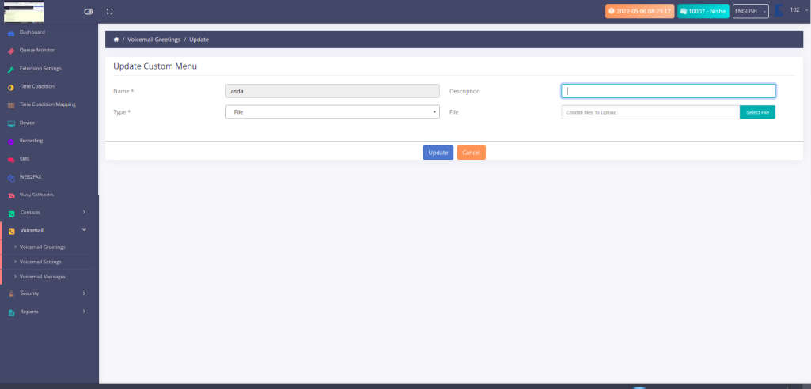

Fig16_03:Voicemail Greetings

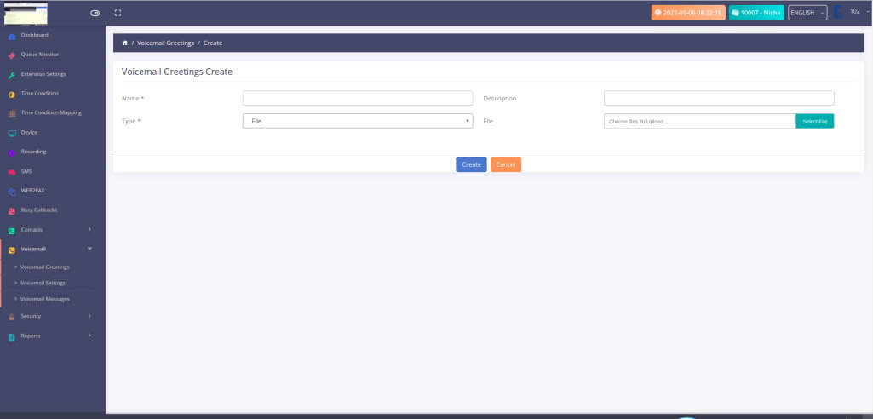

Fig16_4:Voicemail Greetings

# Proposed Enhancements

* + In future planning we are planing to add social media integration in this product if it is possible so it is very easy to manage a social media of a call center and send a marketing photos and many more videos and other things.
  + In future we are planning to put a payment get way automatic to send a salary to all person based on there work timing.
  + This is a main thing for all we want to Enhancement in our product

# Conclusion

* In conclusion I only want to say this is a mainly focus product to call centers only and it make a easy and reliable solution for all call center instead of manual calling systems.
* This system is purely calling product It can manage a call application and many more things and it is easy to understand for a professionals and make a reliable solution for a call centers.

# Bibliography

* [**http://www.stackoverflow.com**](http://www.stackoverflow.com/)
* **https:**[**//www.free-css.com/free-css-templates**](http://www.free-css.com/free-css-templates)
* **https:**[**//www.w3schools.com/**](http://www.w3schools.com/)
* **https:**[**//www.yiiframework.com/**](http://www.yiiframework.com/)